Section 14 , in the previous section we trained an ANN model. In this section we will use RNN model

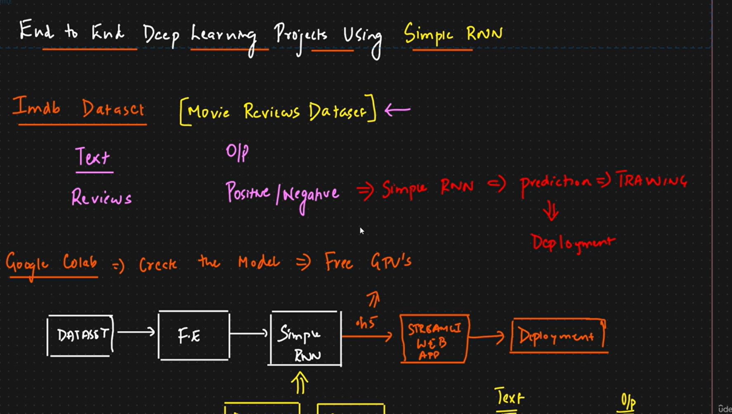
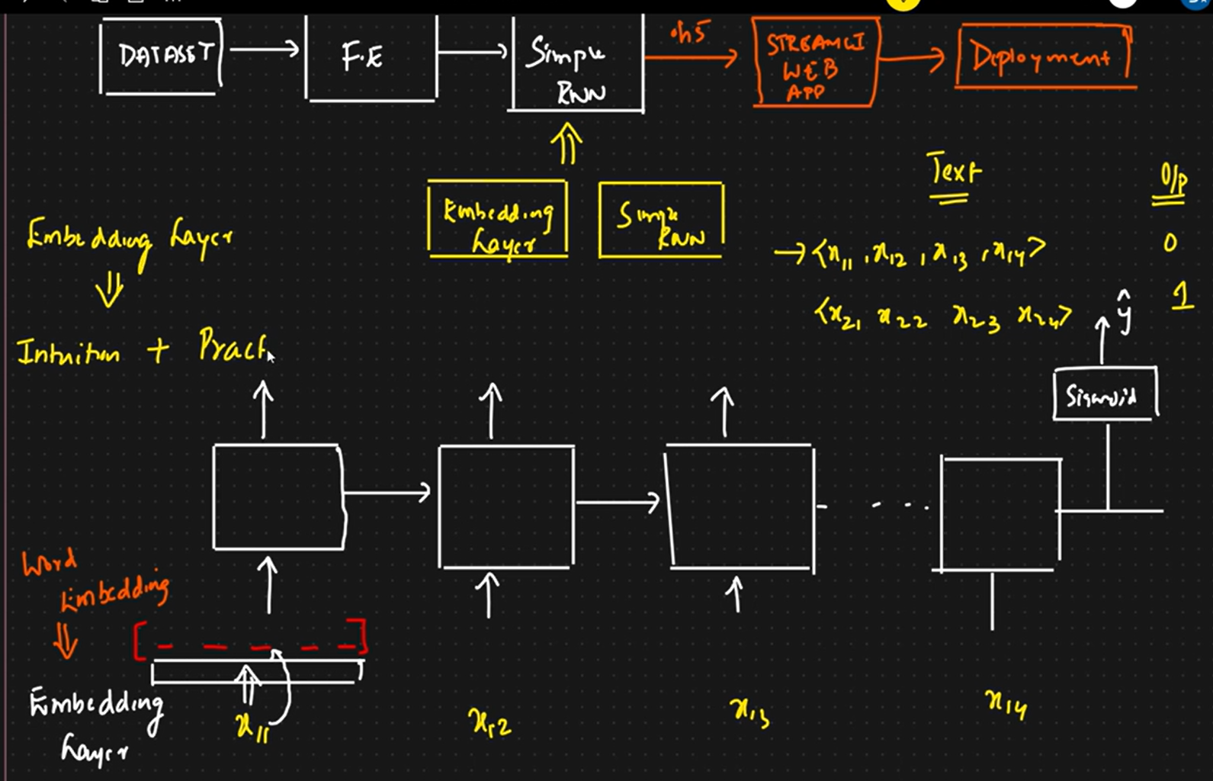

issues with one hot encoding, it is sparce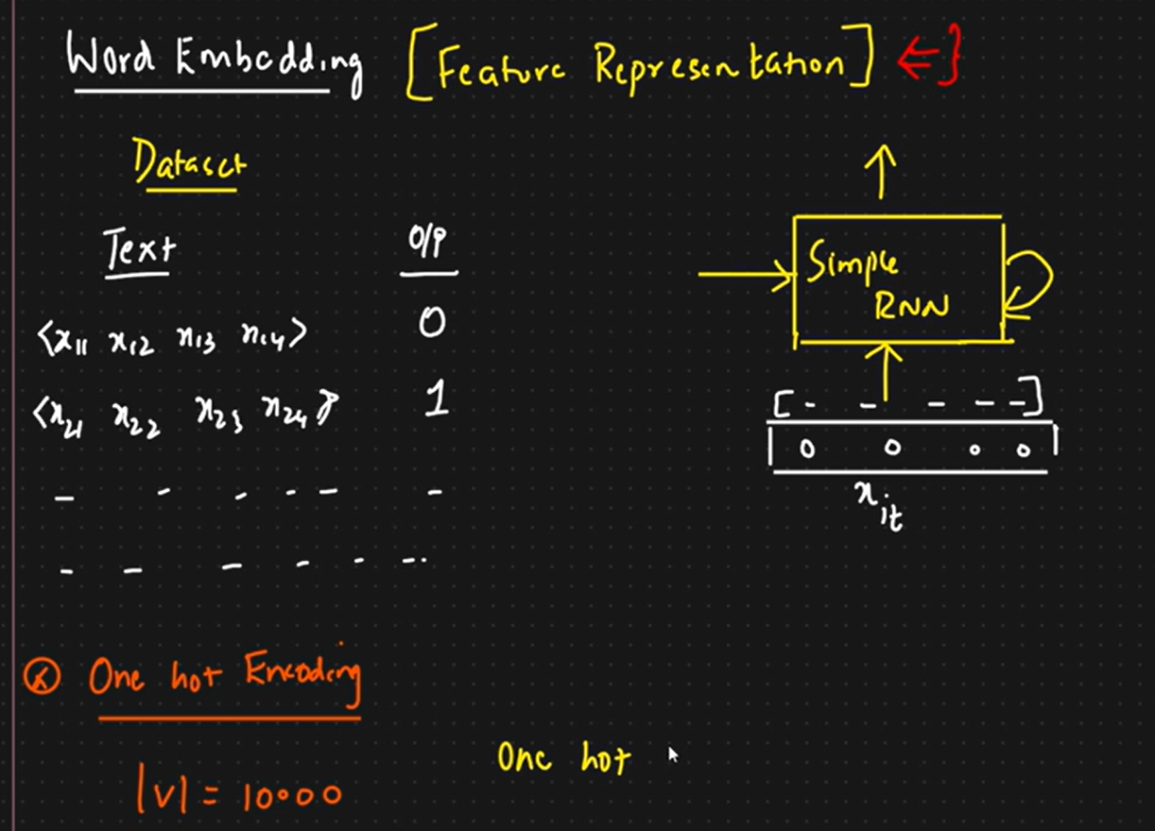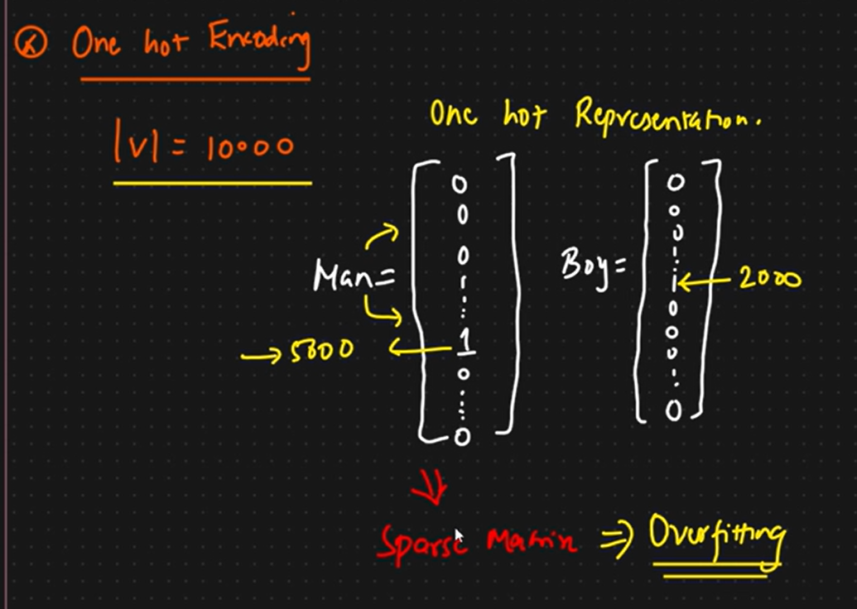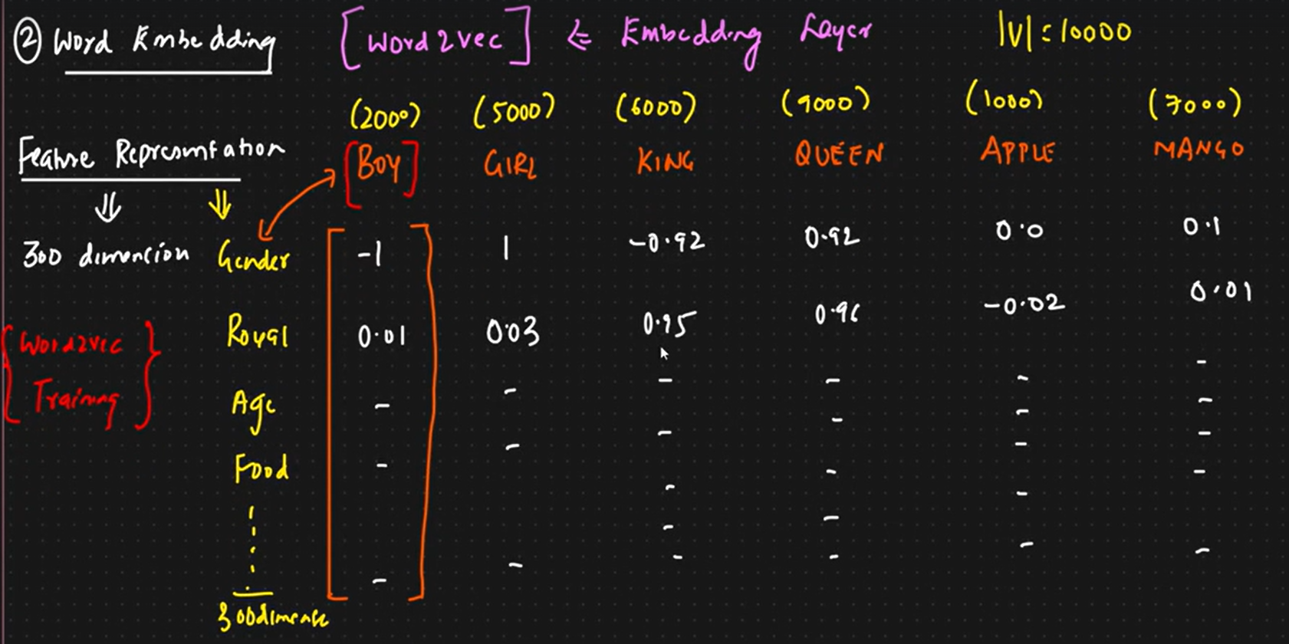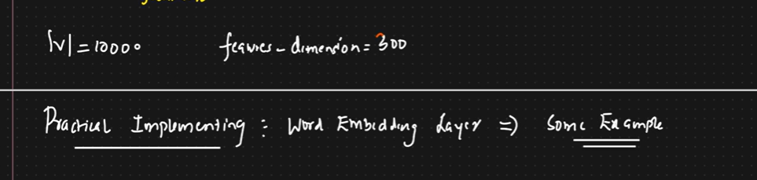

In this tutorial we will understand the embedding layer where the data set(text) is converted to vectors using word2vec, that we discussed in previous video..And also mathematical intuition and practicality. This will be a separate layer

